Lab Exercise 3- Deploy a 4-node MNMD cluster using systemd and validate cluster readiness Cluster

Objective
Deploy a 4-node distributed MinIO cluster with 4 drives on each node (total 16 drives), test bucket operations, simulate disk and node failure, observe healing and rebalancing.

Architecture
Node | IP Example | Drives
Node-1 | 192.168.1.10 | /mnt/disk1 /mnt/disk2 /mnt/disk3 /mnt/disk4
Node-2 | 192.168.1.11 | /mnt/disk1 /mnt/disk2 /mnt/disk3 /mnt/disk4
Node-3 | 192.168.1.12 | /mnt/disk1 /mnt/disk2 /mnt/disk3 /mnt/disk4
Node-4 | 192.168.1.13 | /mnt/disk1 /mnt/disk2 /mnt/disk3 /mnt/disk4

Total drives = 16
Erasure coding parity = 4 (EC:4)
MinIO survives any 4 drive failures or 1 node outage.

Prerequisites
- 4 Ubuntu 20.04/22.04 Servers
- sudo privileges
- All servers can SSH each other
- MinIO binary installed on all nodes:
wget https://dl.min.io/server/minio/release/linux-amd64/minio
chmod +x minio
sudo mv minio /usr/local/bin/

STEP 1 — Create 4 Loopback Virtual Drives on Each Node
Run on each node:
sudo mkdir -p /minio-disks

cd /minio-disks
sudo fallocate -l 1G disk1.img
sudo fallocate -l 1G disk2.img
sudo fallocate -l 1G disk3.img
sudo fallocate -l 1G disk4.img

Attach loopback devices:
sudo losetup -fP /minio-disks/disk1.img
sudo losetup -fP /minio-disks/disk2.img
sudo losetup -fP /minio-disks/disk3.img
sudo losetup -fP /minio-disks/disk4.img

Check:
losetup -a

STEP 2 — Format as XFS & Mount
sudo mkfs.xfs -f /dev/loop3
sudo mkfs.xfs -f /dev/loop4
sudo mkfs.xfs -f /dev/loop5
sudo mkfs.xfs -f /dev/loop6

sudo mkdir -p /mnt/disk1 /mnt/disk2 /mnt/disk3 /mnt/disk4

sudo mount /dev/loop3 /mnt/disk1
sudo mount /dev/loop4 /mnt/disk2
sudo mount /dev/loop5 /mnt/disk3
sudo mount /dev/loop6 /mnt/disk4

sudo chown -R ubuntu:ubuntu /mnt/disk*

STEP 3 — Set MinIO Credentials
export MINIO_ROOT_USER="minioadmin"
export MINIO_ROOT_PASSWORD="Minio@12345"

STEP 4 — Start Distributed MinIO Cluster
Run on every node but change IPs accordingly:
minio server \
http://192.168.1.10/mnt/disk{1...4} \
http://192.168.1.11/mnt/disk{1...4} \
http://192.168.1.12/mnt/disk{1...4} \
http://192.168.1.13/mnt/disk{1...4} \
--console-address ":9001"

Expected Output:
Status: 16 drives online
Erasure Coding: EC:4
API: http://192.168.1.10:9000
Console: http://192.168.1.10:9001

STEP 5 — Configure mc & Upload Objects
Install mc:
wget https://dl.min.io/client/mc/release/linux-amd64/mc
chmod +x mc
sudo mv mc /usr/local/bin/

Set alias:
mc alias set local http://192.168.1.10:9000 minioadmin Minio@12345
Create bucket & upload files:
mc mb local/testbucket

echo "sample1" > file1.txt
echo "sample2" > file2.txt

mc cp file1.txt local/testbucket
mc cp file2.txt local/testbucket

STEP 6 — Simulate Drive Failure
mc admin info local

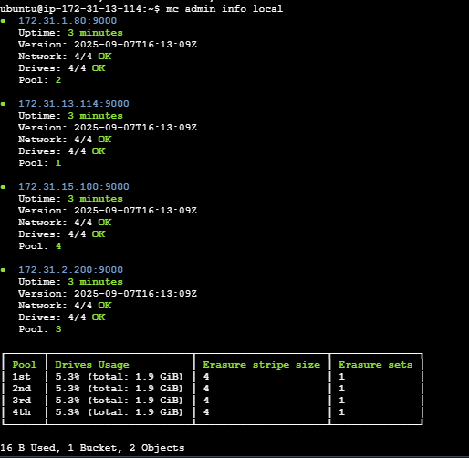
mc admin heal -r local/testbucket

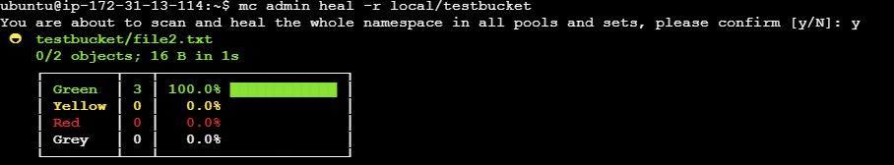
Unmount disk on node-2:
sudo umount /mnt/disk2

mc admin info local

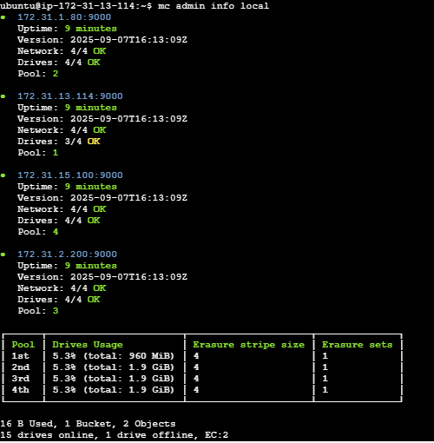
Output expected:
Drive offline
Healing started

STEP 7 — Check Healing
mc admin heal -r local/testbucket

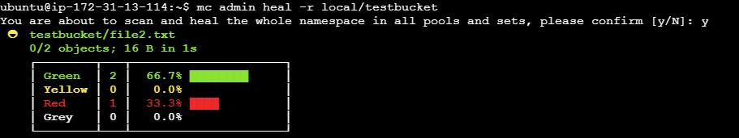
STEP 8 — Simulate Node Failure
Shutdown node-3:
sudo shutdown now
Cluster continues operating (tolerates 1 full node down):
mc admin info local

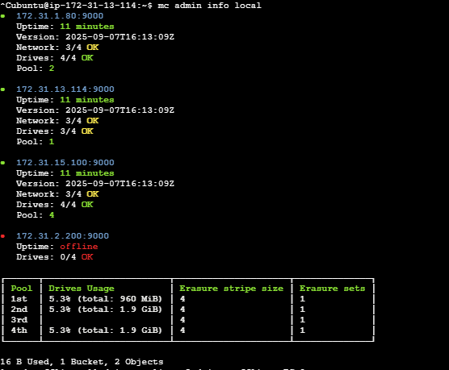

STEP 9 — Verify Data
mc ls local/testbucket

You should still see all uploaded files.

